How to use your Spiromax inhaler
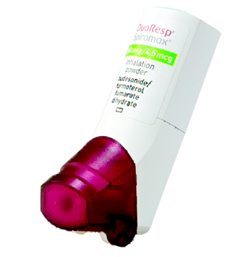
Inhalers are commonly prescribed for patients with asthma and chronic obstructive pulmonary disease (COPD) as they are very effective at delivering the medication straight to the lungs where it is needed.
Using your inhalers correctly is an important part of asthma or COPD treatment. You should be shown how to use inhalers properly by a healthcare professional when they are first prescribed.
You may occasionally experience problems using your inhalers, especially if it has been a while since you were shown the correct technique. This is very common and your healthcare professional can help you improve your inhaler technique.

Why is inhaler technique important?
- It allows the correct dose of medication to reach your lungs.
- It gives you better control of your condition.

Examples of Spiromax inhalers | DuoResp Spiromax

Checklist for Spiromax use
1 | Stand or sit upright when using your Spiromax.
2 | Hold the Spiromax upright with the mouthpiece facing down; take care not to block the air vent.
3 | Open the mouthpiece cover by folding it down until you hear a loud click.
4 | Breathe out gently as far as is comfortable away from mouthpiece and do not breathe in again yet.
5 | Place the mouthpiece between your teeth without biting and form a good seal around it with your lips.
6 | Breathe in through your mouth as deeply and hard as you can.
7 | Hold breath for about 10 seconds or as long as is comfortable.
8 | Remove the Spiromax from your mouth.
9 | Breathe out gently and slowly away from mouthpiece.
10 | Close the mouthpiece.
11 | If you need to take a second dose repeat steps 3 to 10.

Common problems
Common mistakes that people make with Spiromax include:
- Not standing or sitting up to take the Spiromax.
- Not holding the Spiromax upright during use.
- Blocking the air vent.
- Not inhaling strongly enough to draw the medication out of the Spiromax and in to your lungs.
- Breathing out through the Spiromax (remove the Spiromax from your mouth first).
- Not holding your breath long enough after breathing in the contents

Useful tips
- Always hold the Spiromax upright, take care not to block the air vent.
- You may notice a taste when you inhale the medicine.
- Always close the mouthpiece after use.
- Do not open and close the mouthpiece unless you are going to use the Spiromax.
- If your inhaler contains a steroid rinse your mouth with water after every dose, and spit it out.
- When the dose counter turns red, re-order a new inhaler.
- Never wash the Spiromax with water. To clean your Spiromax, wipe the mouthpiece inside and outside with a clean, dry, lint-free cloth to remove any powder residue. Keep the Spiromax dry.
- Speak to your nurse or pharmacist if you experience problems opening or using your Spiromax.
- Always read the patient leaflet provided with your Spiromax for any specific instructions.

How did I do?

For video demonstrations on how to use your inhaler visit:

https://player.vimeo.com/video/179442880

Ensure that you have your respiratory condition and inhaler technique reviewed at least annually

